**DOCUMENTS MANAGEMENT SYSTEM FOR SLSU-KNOWLEDGE TRANSFER AND TECHNOLOGY OFFICE**

A Final Project

Presented to the Faculty of the

College of Computer Studies and Information Technology,

Southern Leyte State University

In Partial Fullfillment of the Requirements

for the degree Bachelor of Science in Information Technology

By

Abrea, Julie Ann

Calindao, Ian

Cano, Juvie

Costillas, Jelly Ann

Obra, Jheselle

Rivas, Ronald

Mr. Keano Nikko L. Sy

Adviser

December 2022



MAIN CAMPUS

San Roque, Sogod, Southern Leyte

Email: [president@southernleytestateu.edu.ph](mailto:president@southernleytestateu.edu.ph)

Website: www.southernleytestateu.edu.ph

Excellence | Service | Leadership and Good Governance | Innovation | Social Responsibility | Integrity | Professionalism | Spirituality

***College of Computer Studies and Information Technology***

**APPROVAL SHEET**

The Capstone Project Study entitled DOCUMENT MANAGEMENT SYSTEM FOR SLSU-KNOWLEDGE TRANSFER AND TECHNOLOGY OFFICE prepared and submitted by Abrea , Calindao , Cano , Costillas , Obra , Rivashas been examined and is recommended for approval and acceptance.

RECOMMENDED:

KEANO NIKKO L. SY, MSITJAMES BRIAN FLORES, DIT

Adviser ITSO Manager Capstone Facilitator

APPROVED by the Committee on Oral Examination with a grade of PASSED on December 19, 2022

GERALDINE MANGMANG, DIT

Chairman

GILBERT SIEGA, MSIT CZARINA ANCELLA GABI, PHD, TM

Member Member

JIMSON OLAYBAR, MSIT

Member

ACCEPTED and APPROVED in partial fulfillment for Capstone Project One in partial requirement in Bachelor of Science in Information Technology.

GERALDINE MANGMANG, DIT

Dean, CCSIT

Date: _________________



MAIN CAMPUS

San Roque, Sogod, Southern Leyte

Email: [president@southernleytestateu.edu.ph](mailto:president@southernleytestateu.edu.ph)

Website: www.southernleytestateu.edu.ph

Excellence | Service | Leadership and Good Governance | Innovation | Social Responsibility | Integrity | Professionalism | Spirituality

***College of Computer Studies and Information Technology***

**CAPSTONE SUGGESTION AND COMPLIANCE MATRIX**

Name of Group: Team Unique

Capstone Title: Document Management System for SLSU-KTTO for manuscript

Date: January 18, 2023

|  |  |  |
| --- | --- | --- |
| **COMMENTS/SUGGESTION** | **COMPLIANCE/ACTION MADE** | **REMARKS** |
| 1. Revised the manuscript as to how capstone project 2 will be conducted. | Incorporate already how the capstone project 2 conducted. | Completed |
| 1. Review the tenses and grammars. | The tenses and grammars are already reviewed. | Completed |
| 1. Revised the word “proposal”. | The word “proposal” are already revised. | Completed |
| 1. Revised the figures in your page number in the introductory part. | Already revised the figures in the page number in the introductory part. | Completed |
| 1. Review the bibliography. | Already reviewed the bibliography | Completed |

KEANO NIKKO L. SY, MSIT

Research Adviser

Approved by:

GERALDINE MANGMANG, DIT

Dean, CCSIT



MAIN CAMPUS

San Roque, Sogod, Southern Leyte

Email: [president@southernleytestateu.edu.ph](mailto:president@southernleytestateu.edu.ph)

Website: www.southernleytestateu.edu.ph

Excellence | Service | Leadership and Good Governance | Innovation | Social Responsibility | Integrity | Professionalism | Spirituality

***College of Computer Studies and Information Technology***

**CAPSTONE SUGGESTION AND COMPLIANCE MATRIX**

Name of Group: Team Unique

Capstone Title: Document Management System for SLSU-KTTO for system

Date: January 18, 2023

|  |  |  |
| --- | --- | --- |
| **COMMENTS/SUGGESTION** | **COMPLIANCE/ACTION MADE** | **REMARKS** |
| 1. Viewing only for the director | Already done. | Completed |
| 1. For maker indicate what type of intellectual property. | The type of intellectual property was already indicated. | Completed |
| 1. Adding of college. | Adding of college was already added. | Completed |
| 1. The whole title of the files should be visible. | The whole title are already visible. | Completed |

KEANO NIKKO L. SY, MSIT

Research Adviser

Approved by:

GERALDINE MANGMANG, DIT

Dean, CCSIT

**Dedication**

Above all, we want to thank our all-mighty God for giving us the courage, strength, and motivation throughout this process.

This research paper is lovingly dedicated to our respective families, friends, and even our groupmates, who have been our constant source of inspiration.

To our Capstone Adviser, who helped, guided, and instructed us on this project, thank you to our instructor, who guided and prepared us to achieve our goals in the future. The process is difficult, but it is not impossible to complete because we are well-rounded by people who are always there to guide us.

Finally, to our Alma Mater, Southern Leyte State University, for giving us the opportunity to nurture and mold our capability and capacity as individuals.

**Acknowledgement**

We consider ourselves quite lucky to have had this support while we worked to complete this project because its success and final outcome required a lot of guidance and help from numerous people. We would want to take this chance to thank them for their advice and assistance in everything we have done.

First of all, we would like to acknowledge our Almighty God for giving us strength, courage and guidance in making this project.

To our parents for their moral and financial support.

We honor and thank Mr. Angel Sabusap for allowing us the chance to interview him and for providing us with all the help and direction we needed to finish the project on time. Despite his hectic schedule overseeing corporate issues, he provided us with a lot of help and guidance, for which we are quite grateful.

We owe a debt of appreciation to our project adviser, Mr. Keanu Sy, who showed a genuine interest in our work and helped us every step of the way until it was finished by giving us the knowledge required to create a solid project.

To Mr. Rhoderick Malangsa, our CAPSTONE 1 instructor, for teaching, advising, supporting, and encouraging us, as well as for giving us the chance to produce this project.

To Mr. James Brian Flores, our CAPSTONE 2 instructor, for teaching, advising, supporting, and encouraging us, as well as for giving us the chance to produce this project.

We are appreciative and lucky to have received ongoing support, encouragement, and direction from the CCSIT Department's teaching team, which enabled us to successfully complete our project work. We also want to express our gratitude to the entire laboratory personnel for their prompt assistance.

**Table of Contents**

**Title Page** ..........................................................................................................................................

**Approval Sheet**..................................................................................................................................

**Matrix** ................................................................................................................................................

**Dedication** ....................................................................................................................................

**Acknowledgement** ......................................................................................................................

**Table of Contents** ....................................................................................................................

**List of Figures**  ........................................................................................................................

**Table**  ........................................................................................................................

**Chapter I – Introduction**

* Introduction .............................................................................................................1
* Project Context ............................................................................................................1
* Purpose and Description of the Project ..............................................................................2
* Objective of the study ........................................................................................................2
* Scope and Limitations of the Project ............................................................................2

**Chapter II – Review of Related Literature**

* Related Literature / Theoretical Background ..............................................................3
* Related Studies ...........................................................................................................5

**Chapter III – Technical Background**

* Technicality of the Project .................................................................................................6
* Details of the Technologies to be use .................................................................................6
* How the project will work .........................................................................................8

**Chapter IV – Methodology**

* Requirements Analysis ....................................................................................................10
* System Requirements .......................................................................................................10
* Input
* Process
* Output
* Performance
* Security Control
* Data and Process Model ....................................................................................................11
* Data flow Diagram.............................................................................................................12
* System Flow Chart ............................................................................................................14
* Object Modeling................................................................................................................16
* Use Case
* Risk Assessment or Analysis.............................................................................................17
* Design of the Software......................................................................................................17
* The Interface Design of the system...................................................................................23
* System Process..................................................................................................................34
* Development and testing...................................................................................................34
* Software Development
* Hardware Specification
* Software Specification
* Testing ...............................................................................................................................35
* Description of the system...................................................................................................35
* Implementation .................................................................................................................36

**Chapter V – Recommendation**

* Recommendation .............................................................................................................37
* Bibliography ....................................................................................................................38
* Appendices
* Relevant Source Code .......................................................................................................40
* Curriculum Vitae ...........................................................................................................43

List of Figures

**Figure 1. Feature-Driven Development** .....................................................................................8

**Figure 2. Architectural Layout** ...............................................................................................9

**Figure 3. The Context Diagram** ............................................................................................11

**Figure 4. Data Flow Diagram for Patent Drafter or Director** ..........................................12

**Figure 5. Data Flow Diagram for Maker** .............................................................................13

**Figure 6. System Flow chart for Patent Drafter** ..................................................................14

**Figure 7. System Flow chart for Maker** ................................................................................15

**Figure 8. The Systems Use Case for Director and Patent Drafter** .....................................16

**Figure 9. The Systems Use Case for Maker** ........................................................................16

**Figure 10. Database schema of the developed system** ............................................................17

**Table**

**Table 1.Risk Assessment or Analysis**..........................................................................................26

**Table 2. Table Dictionary**............................................................................................................27

**Table 3. Software Specification**..................................................................................................44

**Chapter I**

**Introduction**

In our modern world, technology has become the most popular and it helps us to finish our tasks easily, makes our life faster, better, and more enjoyable as a result of all of these revolutions and also to assist us to make our world better. Technology is becoming quicker, more portable, and more powerful than they have ever been.

The Document Management System for KTTO or Knowledge Transfer and Technology Office has two branches: the ITSO or Innovation and the Technology Support Office and IPTBIC or Intellectual Property Technology and Business Incubation Center. DMS manages the entire document lifecycle process and provides tools for managing a wide range of documents securely.

The Document Management System is a method of tracking, managing, and storing documents that reduce the use of paper. Only the patent drafter has access to the various versions created and modified by different users.

**Project Context**

The Document Management System is extremely effective at completing duties and alleviating KTT Office problems. This method will be based on the KKT office's problem. This project attempts to develop a usable system that is available to everybody while yet maintaining the privacy of each file's information.

Every file that the ITSO office possesses is difficult to manage. Excel, Matrix, and Google Docs are being used to manage the data they received from the maker or innovator and its not wise for the files isn't well organized, which is a little concerning. Privacy is not guaranteed or protected. Developing a management system for the KTT Office that is accessible to anybody who is authorized and also to the maker or innovator or inventor, it allows the maker to see the information but only his/ her studies.

Everyone can see this type of information, but only those who are authorized to examine. To ensure that the privacy of all information is safeguarded, no information should be editable by anybody who isn't permitted to do so. It will also work on any device, including a computer, laptop, or smartphone. This system requires a robust internet connection for data transfer to have good performance and quality. It is very easy to learn and use for people.

**Purpose and Research and Description**

The purpose of this project is to provide a Documents Management System for KTT Office so that they can find the files or documents in a less hassle and in a faster way. The proponents aims to develop this system to lessen the burden of every staff while finding every file that they have**.** Document management refers to the take down, monitoring, and handling of electronic information such as Pdf files, word processing files, and digital images of paper-based content. Document management can help you save both money and effort.

**Objective of the Project**

The main objective of this study is to develop a Document Management System that will track and manage the files in the Knowledge Transfer and Technology Office specifically:

1. To create a technology system that can provide effective and accurate transaction monitoring of documents in KTTO.
2. To create a secure and well organized database.

**Scope and Limitations of the Project**

This system will be implemented in the KTTO of SLSU-Main Campus. The system will only track the KTTO documents. Only the KTTO authorized personnel and the faculty members involved have the authority to monitor their documents.

**Chapter II**

**Review of Related Literature**

**Related Literature/Theoretical Background**

A document, according to Abbasova (2020), is a container of information that contains written or drawn information for a specific purpose.

The article Document Management System by [Mahendra](http://ieeexplore.ieee.org/search/searchresult.jsp?searchWithin=%22Authors%22:.QT.Mahendra%20K.%20Ugale.QT.&newsearch=true) et. al., (2017). Paperless Document Management Systems are used to reduce business losses caused by physical paper files and filing systems. Furthermore, the increased volume of document production and distribution via e-mail systems has exacerbated issues with document security, control, tracking, and retrieval.

Implementing an electronic document management system (EDMS) would be a solution to those problems. According to Yatin et al. (2015), an electronic document management system typically refers to a computerized system that facilitates the creation, capture, organization, storage, retrieval, manipulation, and controlled circulation of documents in electronic format. This system will make it easier for the organization to locate and retrieve its files. As a result, EDMS is an essential component in creating a virtual work environment and transforming the capabilities of a modern organization and its workforce (Jones, 2012).

Elsa (2017)'s goal in developing an electronic document management system is to provide an electronic document management system that improves document clustering, categorizing, searching, and retrieval. Because the current study developed the DMS using PHP as the scripting language, the platform used in the study differs. The system included document searching and retrieval capabilities. An electronic document management system aids in the electronic management of documents and ensures the security of information. The study by AKAY et al. (2019) is a "Document Management System (DMS)" that is used for web-based and systematic document management and follow-up, and it is intended to be used as a document management system in public institutions and universities. Web-based applications facilitate content access while lowering storage and printing costs. A recent study by Adam Uzialko (2021) that document management software is an increasingly critical part of any business in the digital era. Instead of rows of filing cabinets, document management systems create an electronic archive that any permissioned user can access and edit. A document management system can improve efficiency for you and your staff by organizing all of your files and making them easy for anyone in the organization to find. A document management system (DMS) is a type of document or file system that is used to organize and track files. Web-based applications make access to content easier, reducing storage and printing costs. According to Malyon (2016), the CEO of MaxxVault, the company provides electronic document management systems and cloud document management solutions to small, medium, and large businesses across a wide range of industries. It saves money by automating tasks and increasing productivity. Every business generates document records and other digital content. In the study of Kao and Tiu (2013), a document management system is designed to provide two main benefits: timely access and support for efficient document sharing and collaboration. The Enhanced Document Management system is a document management system for small to medium organizations for efficient management of electronic documents in their organization (Agarkar et.al., 2012).

**Related Studies**

According to Stallings (2012), a file management system is a collection of system software that aids users and applications in the use of files. The file management system is typically the only mechanism for a user or application to access files. This eliminates the need for the user or programmer to create custom software for each application and gives the system a consistent, well-defined method of controlling its most valuable asset.

The goal of a file management system is to meet the user's data management needs and requirements, which include data storage and the ability to perform the aforementioned operations; to ensure, to the extent possible, that the data in the file is valid; and to optimize performance, both from a system and user perspective in terms of overall throughput and user response time; to provide I/O support for a variety of storage device types; to minimize or eliminate the risk of data loss or destruction; to provide a standardized set of I/O interface routines to user processes; and, in the case of multiple-user systems, to provide I/O support for multiple users.

Anwar and Ahmed (2013) proposed an eCourse file management system to transition from the current method of compiling paper-based course files to a more versatile method of compiling and maintaining electronic course files. The new system provides numerous benefits, including ease of access, information retrieval, and the elimination of storage and disposal issues associated with paper-based files. The system also saves paper and printing costs, reduces the human and financial resources required for course file compilation, minimizes negative environmental impact, saves natural resources for future generations, and contributes to a green, sustainable environment. This system can also be used to track the progress of courses over the course of a semester or year. The proposed system could be enhanced to become a Web-based database system, allowing all input screens and forms to be made available online.

**Chapter III**

**Technical Background**

**Technicality of the project**

Proponents have used web-based programs that users can access via any digital platform. The Document Management System for KTT Office is web-based, making it simple for them to manage documents, and all KTTO staff and researchers have access to it. In our project, the following technical terms are to be used: VS Code – Text Editor, Server-client side and behavior – PHP, HTML, CSS, jQuery, Apache, Database – Xampp, MySQL, Functionality – Web application, PhpMyAdmin. Some of the above-mentioned terminologies are also used in our system's technology.

**Details of the technologies to be used**

This project will be available in any technology to run the system, such as mobile phones, laptops, and computers.

The following technological tools will be used in the project's development:

- We used Microsoft Visual Studio Code to encode the source code of the system throughout development so that data and information could be acquired accurately and quickly. VS Code is designed to provide developers only the tools they need to complete a speedy code-build-debug cycle, leaving more sophisticated processes to others.

- PHP is an HTML-based server-side programming language. It may be used for command-line scripting and client-side GUI programs, as well as managing dynamic content, databases, session tracking, and even building whole e-commerce sites.

- HTML is a markup language that is used to produce electronic texts (called pages) that are displayed on the Internet. This is the language used to create web pages. This is the simplest of the computer languages to learn. We use a Web page editing application to build a Web page without it, but the program will still require HTML to do it.

- CSS is a language for specifying how Web pages are presented, including colors, layout, and fonts. CSS allows web developers to produce an unified appearance throughout several pages of a website by adapting the presentation to

- We decided to use this Javascript library in the development of our system because it is lightweight and will not cause our system to load.

**How the Project Work**

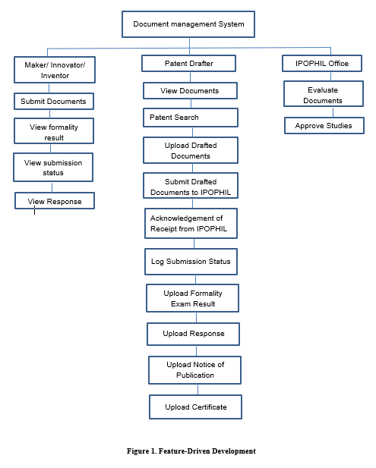

Figure 1. Feature-Driven Development

Figure 1 shows the Feature-Driven Development that the maker will submit documents to the patent drafter through the system. The patent drafter views the documents and do a patent search to ensure that the study has not yet existed. The patent drafter will upload drafted documents such as abstact, claims, figures, and technical detailed summary, then submit it to the IPOPHIL. When the IPOPHIL well acknowledges the receive draft, an acknowledgement receipt is sent to the patent drafter, and the patent drafter will upload it to the system. The patent drafter has a log submission status to put all the information about the documents and all the responses from IPOPHIL. And when the maker will login in the system they can monitor the progress of their application. The patent drafter will upload the formality exam result to the system and then submit a response to IPOPHIL and vice versa until the documents is finally correct. And if the documents are already approved the patent drafter uploaded a notice of publication, and certificate to the system.

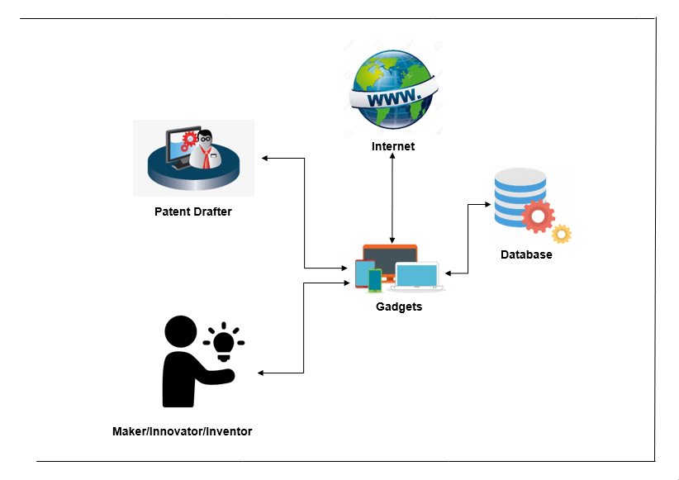Figure 2. Architectural Layout of Documents Management System for SLSU-KTTO

View Responses

Figure 2 presents the architectural layout of the proposed system. The maker will submit documents to patent drafter and the patent drafter will monitor or manage the entire files using PCs, laptops, smartphones, and tablets. Then the documents that are handed by the patent dafter will be saved to the database. The patent drafters are the only ones who manage and upload drafted documents such as abstracts, claims, figures, and technical detailed summaries, then submit them to the IPOPHIL. And whatever response they get from the IPOPHIL, they will upload it into a log submission and the maker can views whatever the formality results, view submission status and also view the response.

**CHAPTER IV**

**Methodology**

A system or process called document management is used to collect, monitor, and store electronic documents like PDFs, word processing files, and digital pictures of paper-based content.

**4.1** **Requirements Analysis**

This study is a developmental method for it is a systematic work drawing on existing knowledge gained from research that is directed to producing a new system. This Document Management System is totally functional and ready to use. These will surely help the Knowledge and Transfer Office to organize their files easily and lessen their burdens unlike paper based.

**4.1.1 Economic Feasibility**

* ***Cost And Benefit Analysis***

Table 1 reflects the lists of the total expenses or costs incurred for the creation of this project. The table reflects that Internet usage has the highest expense due to the proponents’ need to use internet.

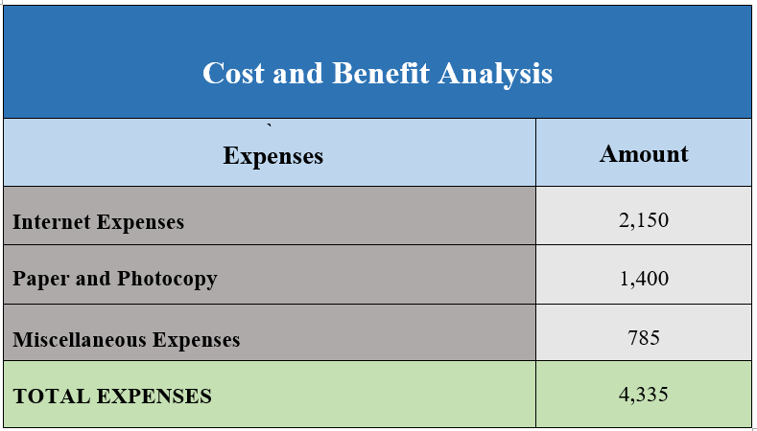

**Table 1. Cost and Benefits Analysis**

* ***Cost Recovery Scheme***

Table 2. Reflects the division of expenses that is reflected in Table 1, in order to gradually pay the costs incurred upon the creation of this project. The costs of expenses also gradually increase every month this is because the project requires lot of requirements in order for this project to be achieved.

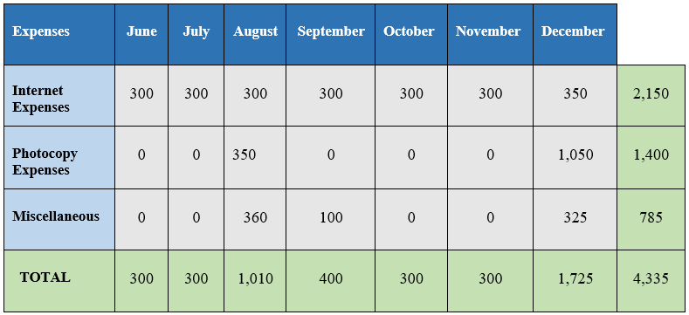

**Table 2. Cost Recovery Scheme**

**4.1.2 Requirements Modelling**

**System Requirements**

The system is called Document Management System for Knowledge and Transfer Office (KKTO). In order to access the systems, it needs a stable internet connection. It will upload and manage all the documents and data.

**Input**

* The user must sign up or create an account.
* The user must have correct login credentials in order to use the system.
* The user needs to submit his/her study.
* The user can view the status of his/her study.
* The director or the patent drafter can view the submitted studies.
* The director or the patent drafter can upload different documents.

**Process**

* The system must authenticate the login credential provided.
* The system can upload, submit, and can accept documents.
* The system can update the log submission.

**Output**

* The system will display the log submission status of the users’ study.
* The system will display the view submission.
* The accepted study will be store in the accepted studies.

**Performance**

* The system is operational anytime.
* Response time must not exceed 5 seconds.
* The system is capable of supporting many online users simultaneously.

**Security and Control**

* The user can edit, change and delete only his/her information and uploaded study.
* The system has separate levels of security for users and the system administrator.

**Data and Process Modeling**



Figure 3. The Context Diagram

Figure 3 presents the context diagram and the basic overview of the whole system or process being analyzed or modeled. The maker will submit a study to the ITSO office through the system, the non-chemical or chemical patent drafter will accept and manage the submitted documents and upload the manage documents to the system, same as to the admin. Whatever uploaded documents in the system can be seen to the corresponding maker and the maker can monitor whatever changes or status of their studies.

The Data Flow Diagram provides a more detailed breakout of pieces of the Context Diagram into sub-processes. Figure 4 are the Data Flow Diagrams - Director, Patent Drafter, and Maker respectively.

**Data Flow Diagram**

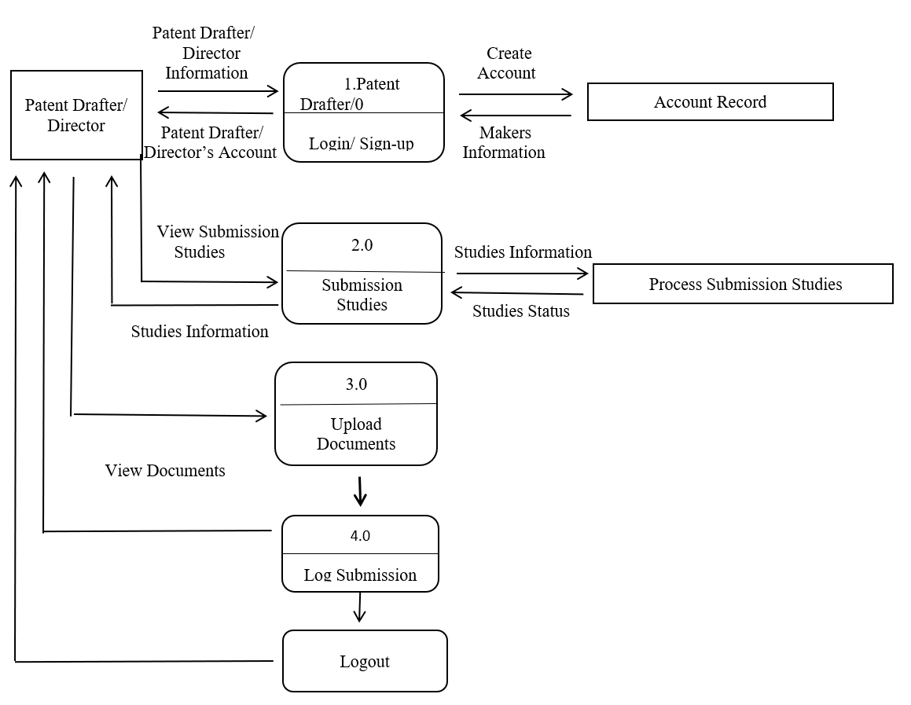

Figure 4. Data Flow Diagram for Patent Drafter/Director

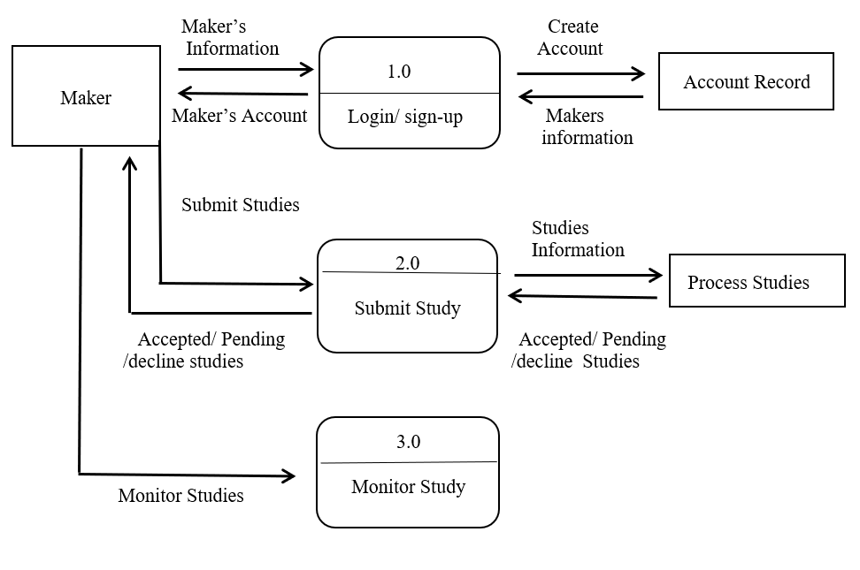

Figure 5. Data Flow Diagram for Maker

**System Flowchart**

Flowcharts are used in analyzing, designing, documenting or managing a process or program in various fields. Its representation illustrates a solution model to a given problem. Shown in Figure are the system flowcharts for each type of user.

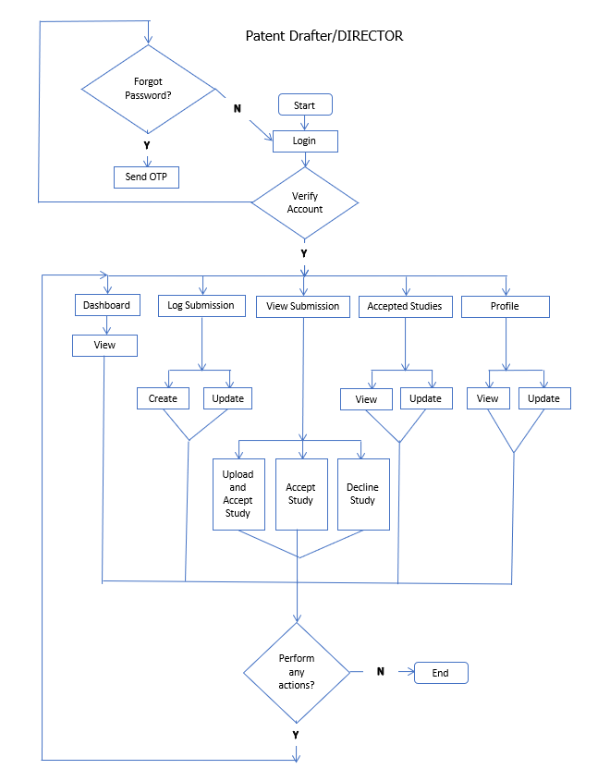

Figure 6. System Flowchart – Patent Drafter/Director

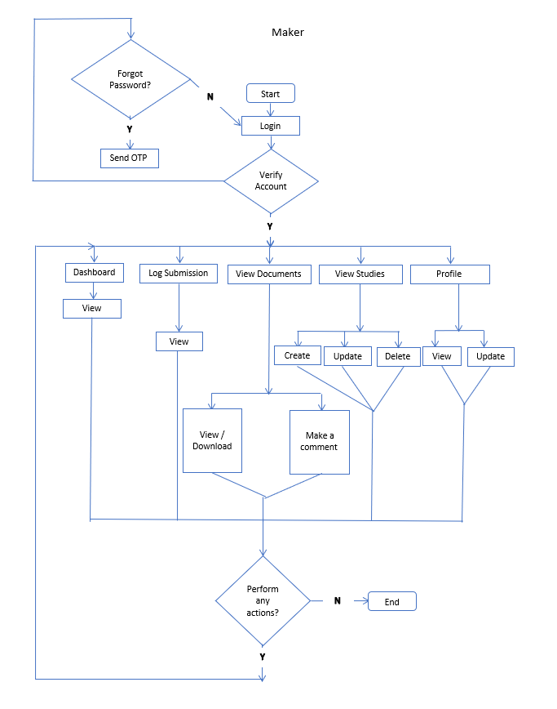

Figure 7. System Flowchart – Maker

**Object Modelling**

**Use Case**

Figure 8 – 9 are the Use Case Models for the proposed system. These are representations of a user’s interaction with the system that shows the relationship between the user and the different use cases in which the user involved.



Login/Sign up

View Submission Studies

Accept Studies

Upload Studies on the System

Upload Documents

Update Log Submission Status

Logout

Director & Patent Drafter

Documents Management System for SLSU-Knowledge and Transfer Office

Figure 8. The System’s Use Case for Director and Patent Drafter



Login/Sign up

Upload Documents

View Documents

Monitor Log Submission

Logout

Maker

Documents Management System for SLSU-Knowledge and Transfer Office

Figure 8. The System’s Use Case for Maker

**Risk Assessment/Analysis**

Table 3. Identifies and analyse all of the potential risks and issues that are detrimental to the Document Management System for KTT Office. The steps to prevent or minimize the occurrence of the identified risk are also presented.

|  |  |  |  |
| --- | --- | --- | --- |
| Risk Description | Effect | Risk Grading  (Low, Medium, High) | Recovery Measure |
| Malware | Possible of data loss, website traffic, and take control of the website itself | High | Install Anti-virus software |
| No internet connection | Cannot access the website | Medium | Connect to another network |

**Design of the Software**

This section discusses the design and implementation of the data structure and algorithms used in the software. It presents the data design that produced the detailed data model of database such as the Data Schema in Figure 9 and data dictionary in Table1-8.

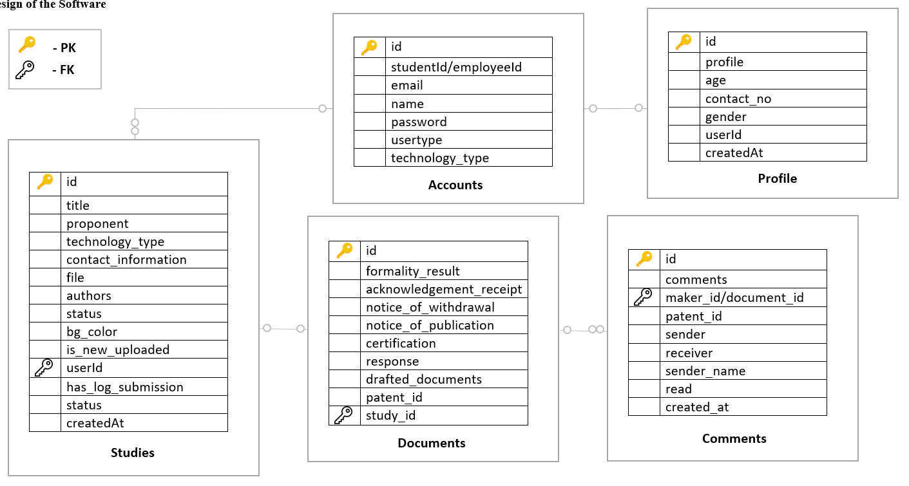

Figure 9. Database schema of the developed system

**Data Dictionary**

**tbl_accounts**

|  |  |  |
| --- | --- | --- |
| **Column** | **Type** | **Comment** |
| **Id** | int (11) Auto Increment | Unique ID of the current table |
| **studentId** | varchar (50) | ID number of a user which is displayed on a user’s school ID |
| **Email** | varchar (50) | Email of a user |
| **Name** | varchar (75) | Fullname of a user |
| **password** | varchar (255) | Unique password of a user |
| **usertype** | varchar (20) | User type of a user if it is a patent drafter or a maker |
| **Technology_type** | varchar (20) | Technology type of a user if it is a non-chemical or chemical |

**tbl_codes**

|  |  |  |
| --- | --- | --- |
| **Column** | **Type** | **Comment** |
| **Id** | int (11) Auto Increment | Unique ID of the current table |
| **Email** | varchar (50) | Password recovery of user through email |
| **Code** | int (4) | User receive an OTP code to reset the user password |

**tbl_college**

|  |  |  |
| --- | --- | --- |
| **Column** | **Type** | **Comment** |
| **Id** | int (11) Auto Increment | Unique ID of the current table |
| **college** | varchar (255) |  |
| **userId** | int (11) |  |
| **default_item** | tinyint (1) |  |

**tbl_comments**

|  |  |  |
| --- | --- | --- |
| **Column** | **Type** | **Comment** |
| **Id** | int (11) Auto increment | Unique ID of the current table |
| **comments** | varchar (10000) | Feedback of the studies |
| **maker_id** | int (11) FK | ID of the study or group chat ID |
| **patent_id** | int (11) | ID of the patent drafter |
| **Sender** | int (11) | ID of the sender |
| **receiver** | int (11) | ID of the receiver |
| **sender_name** | varchar (75) | Name of sender |
| **Read** | tinyint (1) | Status of the feedback |
| **created_at** | varchar (50) | Date of created feedback |

**tbl_documents**

|  |  |  |
| --- | --- | --- |
| **Column** | **Type** | **Comment** |
| **Id** | int (11) Auto increment | Unique ID of the current table |
| **formality_result** | varchar (255) | Drafter upload formality result to the system |
| **acknowledgement_receipt** | varchar (255) | Drafter upload acknowledgement receipt |
| **notice_of_withdrawal** | varchar (255) | Drafter upload notice of withdrawal to the system |
| **notice_of_publication** | varchar (255) | Drafter upload notice of publication to the system |
| **certification** | varchar (255) | Drafter upload formality result to the system |
| **log_submission_status** | varchar (255) | Drafter can add record to the system |
| **response** | varchar (255) | Drafter upload response to the system |
| **drafted_documents** | varchar (255) | Drafter upload drafted documents |
| **patent_id** | int (11) | ID of the patent drafter |
| **maker_id** | int (11) | User ID |
| **study_id** | int (11) | ID of the study |

**tbl_log_submission**

|  |  |  |
| --- | --- | --- |
| **Column** | **Type** | **Comment** |
| **Id** | int (11) Auto increment | Unique ID of the current table |
| **application_no** | varchar (50) | Applied number of the technology |
| **Title** | varchar (75) | Title of the propose study |
| **creator** | varchar (75) | Name of the creator of the study |
| **ip_type** | varchar (10) | If it is Utility Model or INV |
| **college** | varchar (75) | Name of school of the creator |
| **dragon_pay** | varchar (75) | The dragon pay code is from IPOPHIL and the drafter will input it in log submission |
| **application_date** | varchar (50) | When the study applied |
| **Agent** | varchar (50) | Name of the Agent |
| **drafter** | varchar (75) | Name of drafter |
| **document_where_about** | varchar (75) | Where the study came from like inventor or maker |
| **publication_date** | varchar (50) | When the study published |
| **publication_vol** | varchar (10) | Number of publication volume |
| **publication_no** | varchar (10) | Number of publications |
| **registration_date** | varchar (50) | When the study registered |
| **registration_date_vol** | varchar (10) | Number of volumes |
| **registration_date_no** | varchar (10) | Number |
| **examiner** | varchar (50) | Name of the examiner to the study of the creator |
| **Status** | varchar (100) | The status of the creator’s study |
| **remark 1** | varchar (100) | Remarks came from IPOPHIL |
| **remark 2** | varchar (100) | Remarks came from IPOPHIL |
| **office_remark** | varchar (100) | Remarks from the Office |
| **action_step_1** | varchar (75) | Step process of ITS Office |
| **action_step_2** | varchar (75) | Step process of ITS Office |
| **certificate_office** | varchar (100) | The certificate came from IPOPHIL |

**tbl_profiles**

|  |  |  |
| --- | --- | --- |
| **Column** | **Type** | **Comment** |
| **Id** | int (11) Auto increment | Unique ID of the current table |
| **Profile** | varchar (255) | Profile picture of user |
| **Age** | int (11) | Age of user |
| **contact_no** | varchar (11) | Contact number of the user |
| **gender** | varchar (25) | The gender of a user |
| **createdAt** | varchar (75) | Date of created profile |
| **userId** | int (11) FK | ID of the users |

**tbl_studies**

|  |  |  |
| --- | --- | --- |
| **Column** | **Type** | **Comment** |
| **Id** | int (11) Auto increment | Unique ID of the current table |
| **Title** | varchar (75) | Title of the study of user |
| **proponent** | varchar (75) | Fullname of a user |
| **technology_type** | varchar (25) | Type of technology in the user’s study |
| **contact_information** | varchar (11) | Contact number of a user |
| **File** | varchar (100) | The user upload files through system |
| **authors** | varchar (255) | User gmail account |
| **created_at** | varchar (50) | Date when the user upload file |
| **status** | varchar (15) | The user can monitor his/her studies |
| **bg_color** | varchar (25) | The user will know if his/her study is accepted, decline or pending |
| **is_new_uploaded** | tinyint (1) | User can update the file |
| **userId** | int (11) FK | Maker’s ID that create specific study |
| **has_log_submission** | tinyint (1) | In creating a specific study in log submission, it is the one that being based |

**Design of the System**

**The Interface Design of the System**

**Login**

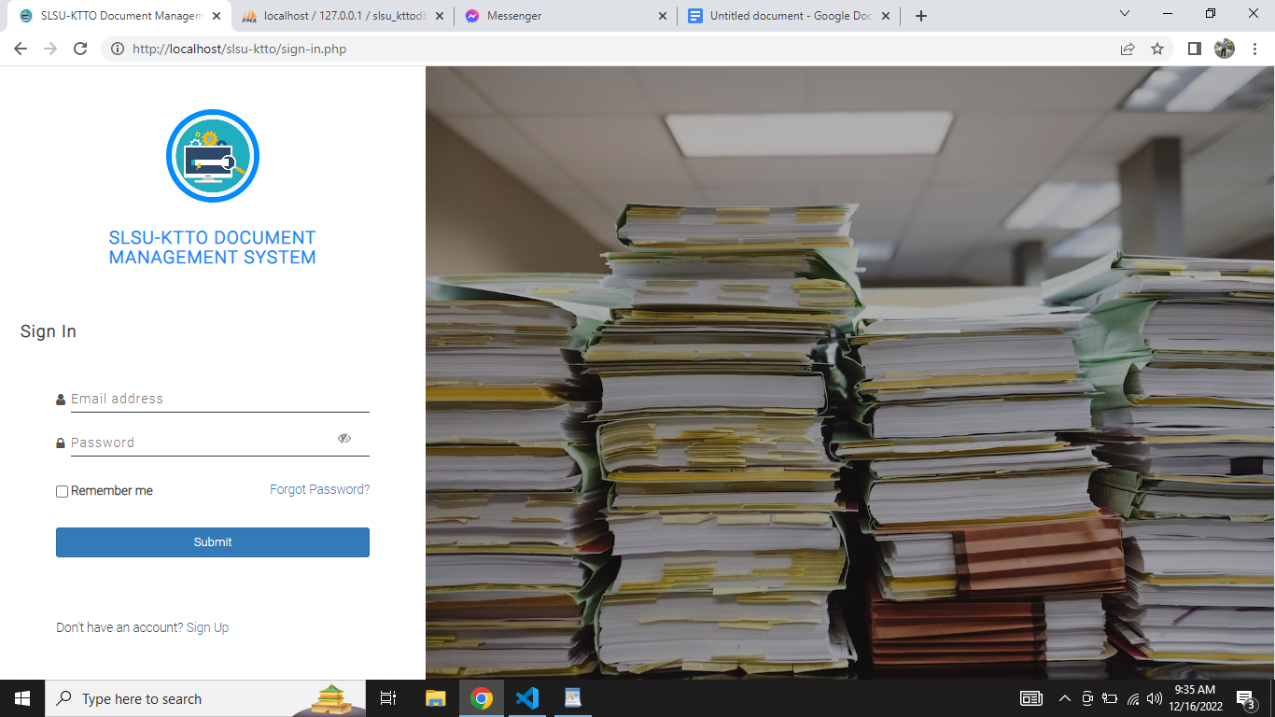

This is the part where the user is allowed to enter their credentials before they can continually access the system.

**Signup**

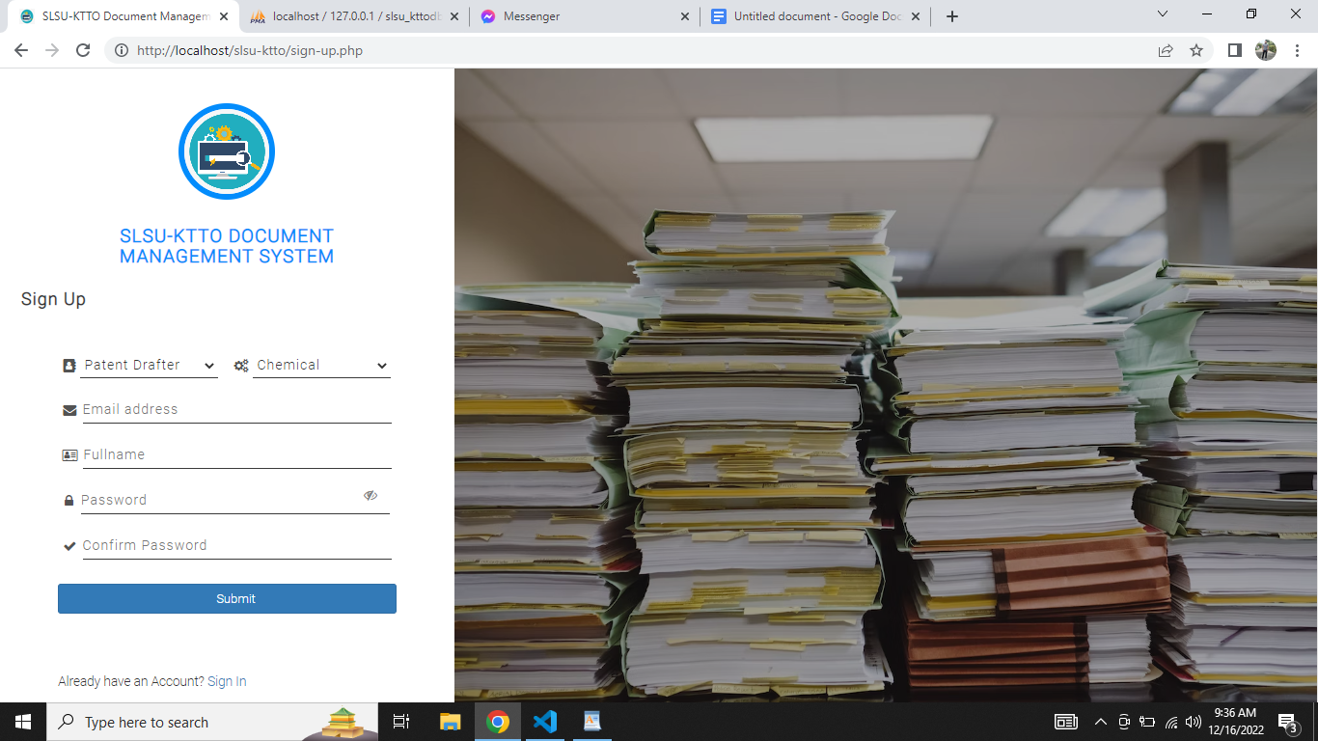

This is the part where the user created their account

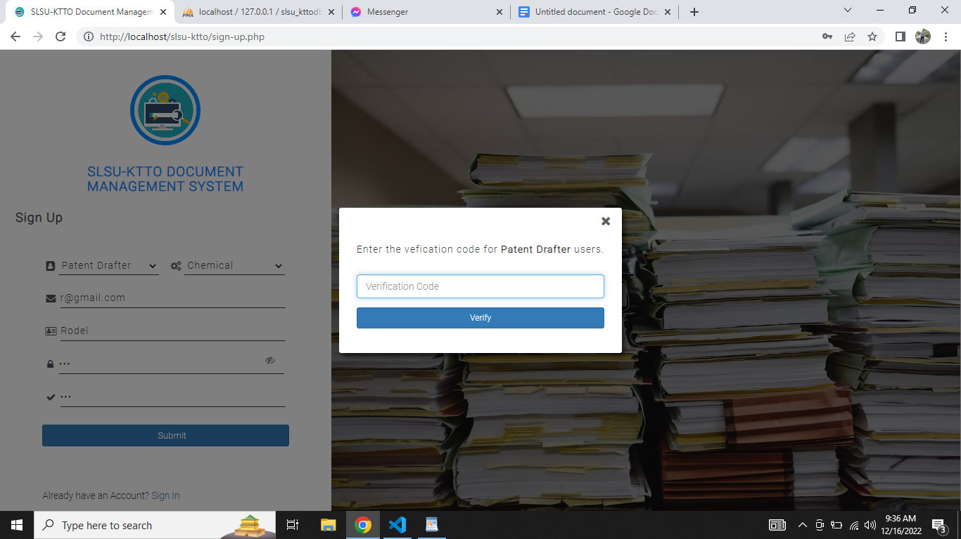

**For Patent Drafter Users**. The patent drafter user is required to enter the verification code. The code was set default as per the developer created the system.

**Password Recovery**

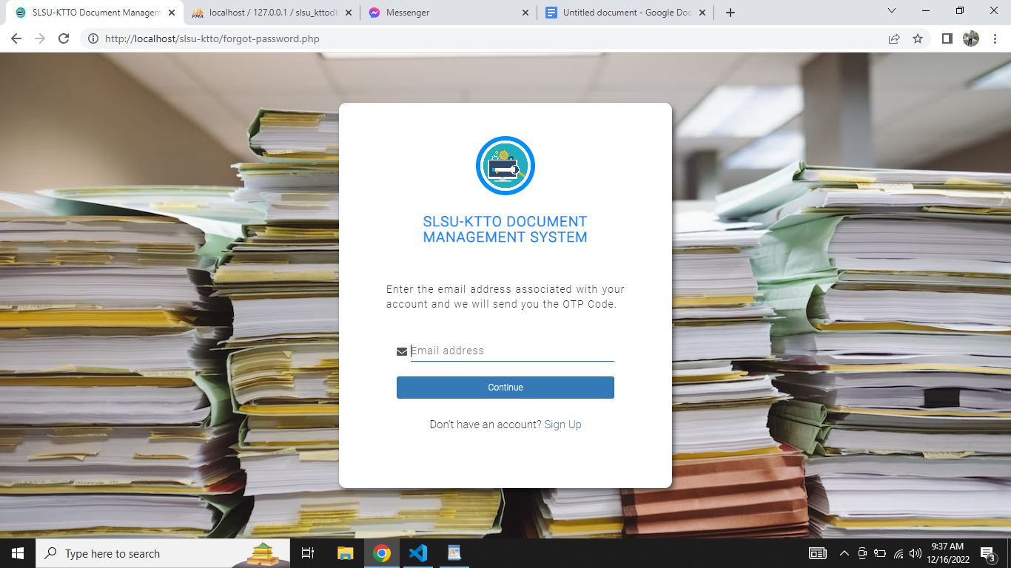

This is the part where the user enters their respective email where the system sends an OTP Code.

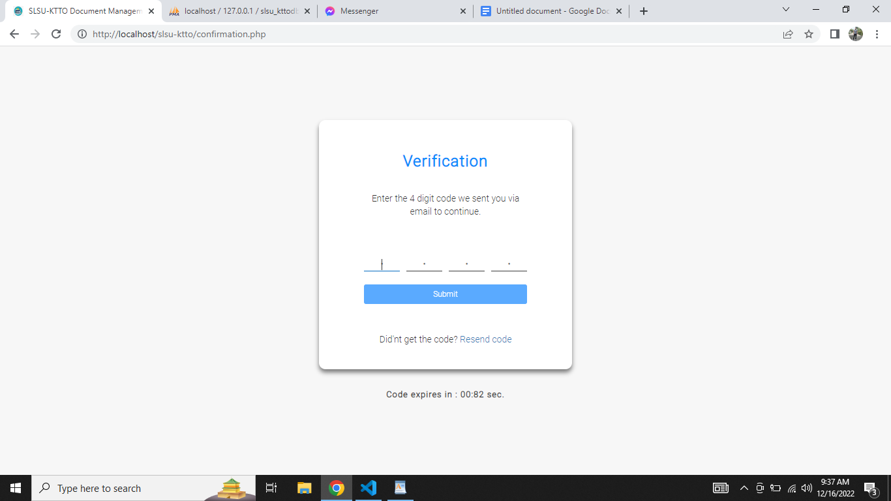

This is the part where the user is redirected after entering the email above.

**Dashboard**

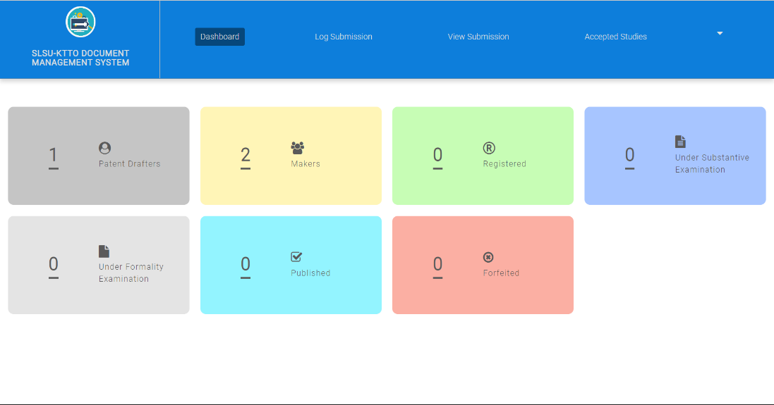

This is the dashboard of the system w/c represents the visual counts on each category.

**Log Submission**

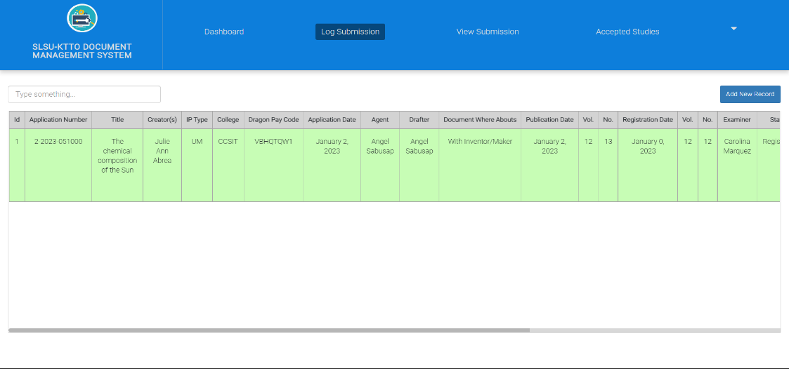

This is the part displaying the list of created log submission records.

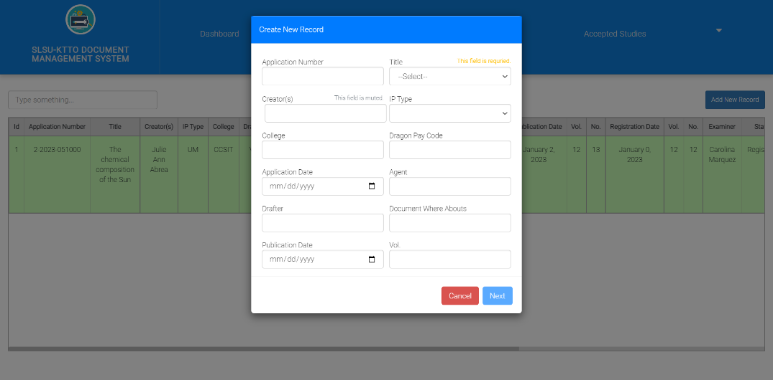

**For Patent Drafter only.** This is the part where the user created a new record for log submission.

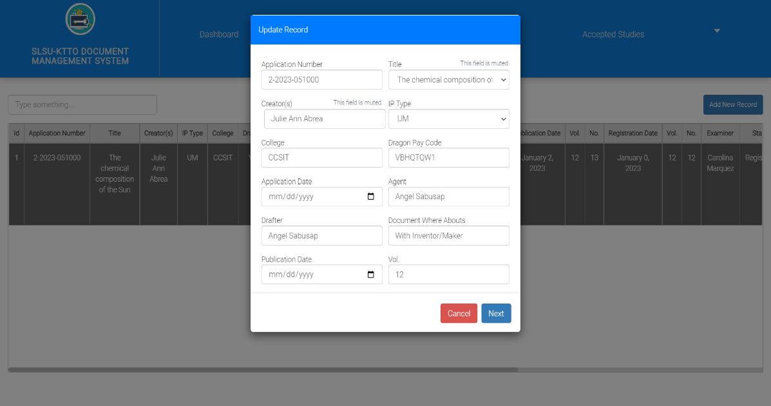

**For Patent Drafter only.** This is the part where the user selects a specific record and performs any changes on it.

**View Submission**

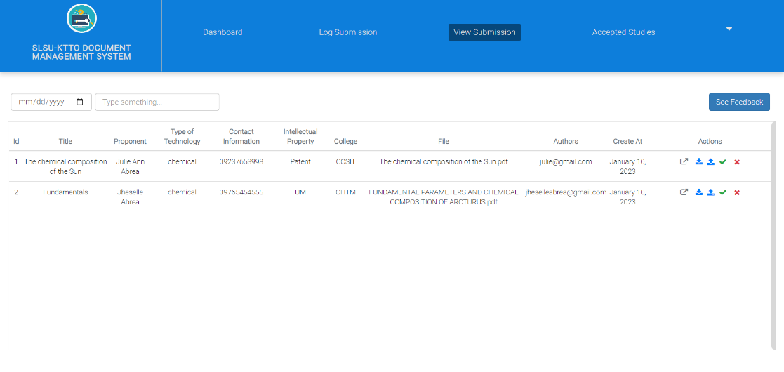

**For Patent Drafter and Director User only.** This is the part which displays the list of created study of makers.

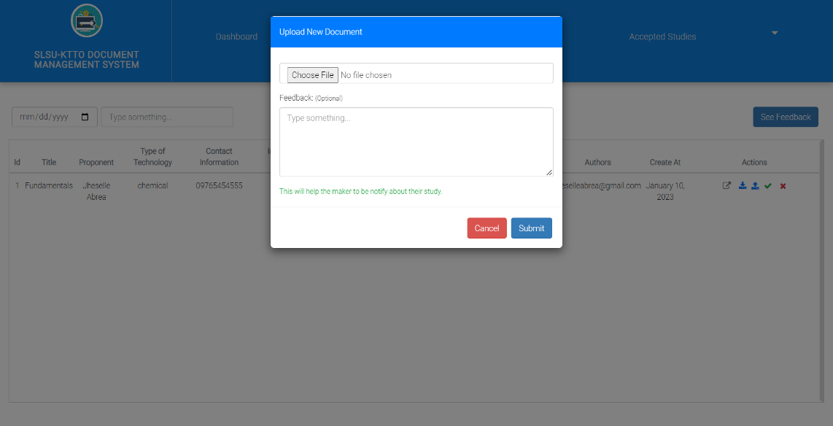

**For Patent Drafter only.** This is the part where the user was done doing patent check and wanted to update or upload a new file for the maker’s study.

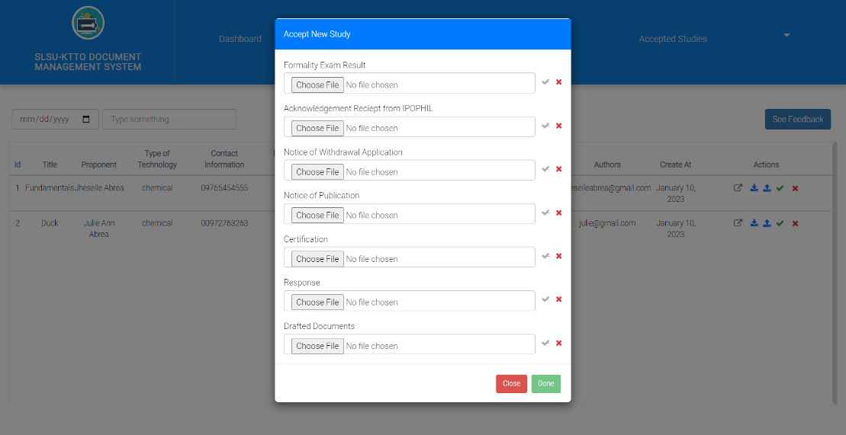

**For Patent Drafter only.** This is the part where the user was done doing patent check and ready to submit the study to IPOPHIL. The user is required to select one or many documents wanted to upload.

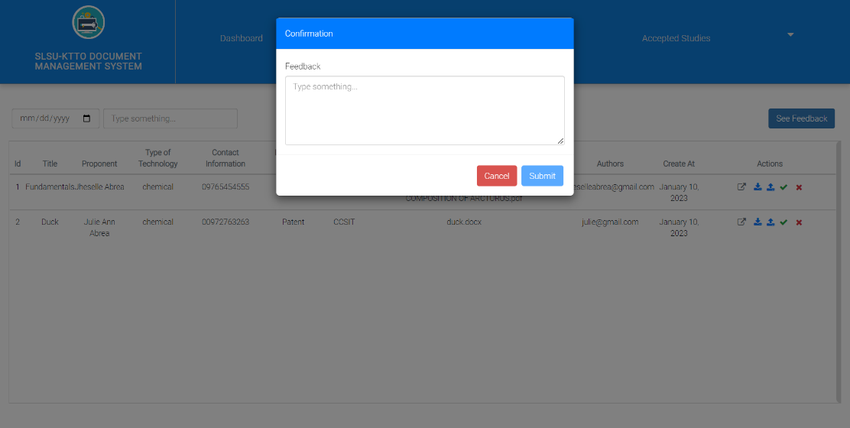

**For Patent Drafter only.** This is the part where the user was done doing patent check and is not satisfied with the submitted study.

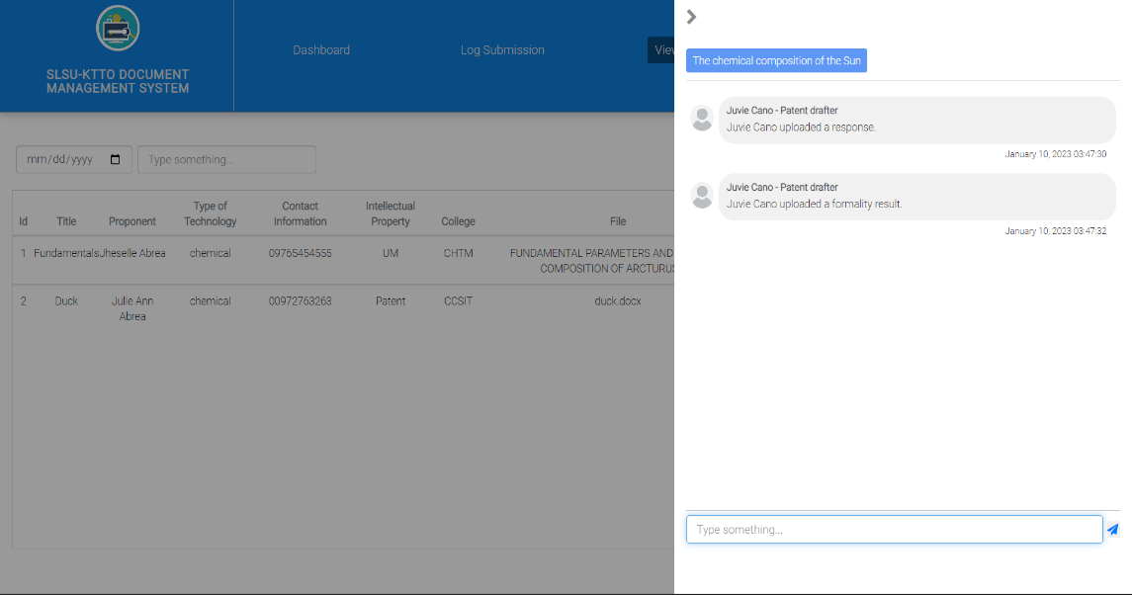

This is the part where the user hits the button “See Feedback”. It shows a side drawer that displays specific comments between the two or three users. (**Director, Makers, Patent drafters.**)

**Accepted Studies**

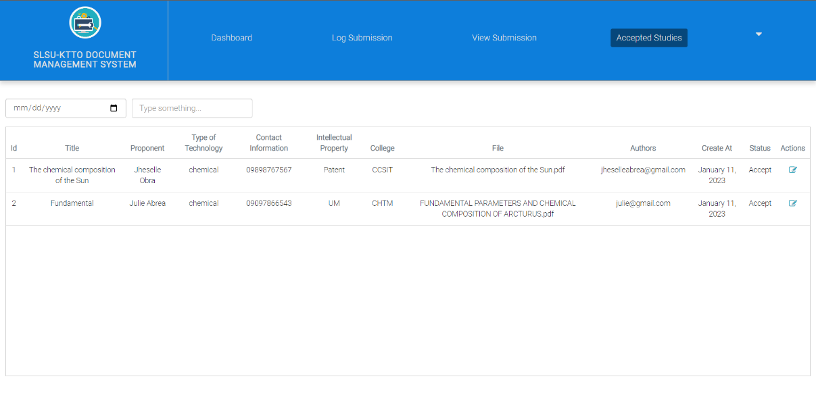

**For Patent Drafter and Director User only.** This is the part which displays the list of accepted studies.

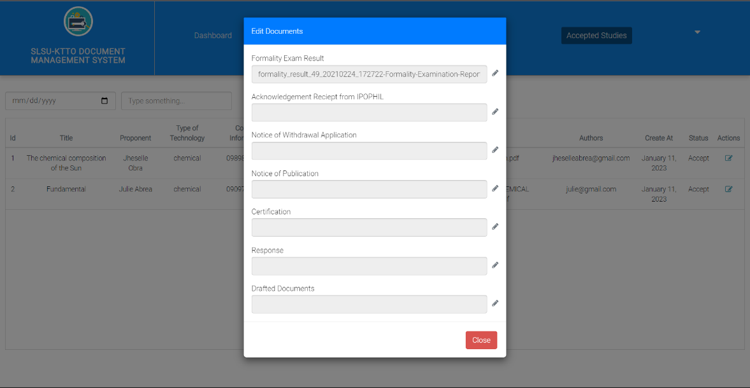

**For Patent Drafter only.** This is the part where the user wanted to update the current document uploaded for the maker.

**Maker Users**

**Log Submission**

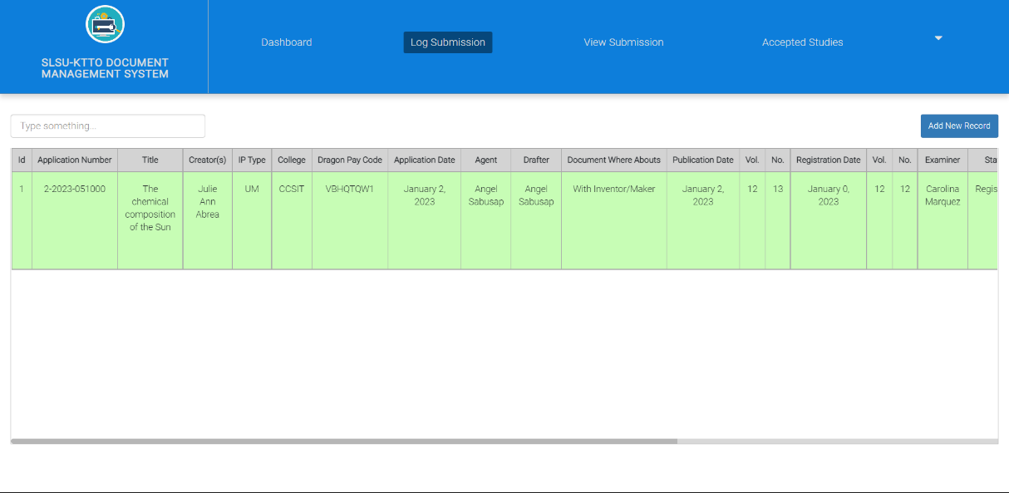

**For Makers User and Director User only.** This is the part which displays the list of current log submissions. The maker and director is not authorized to make any actions on this part.

**View Documents**

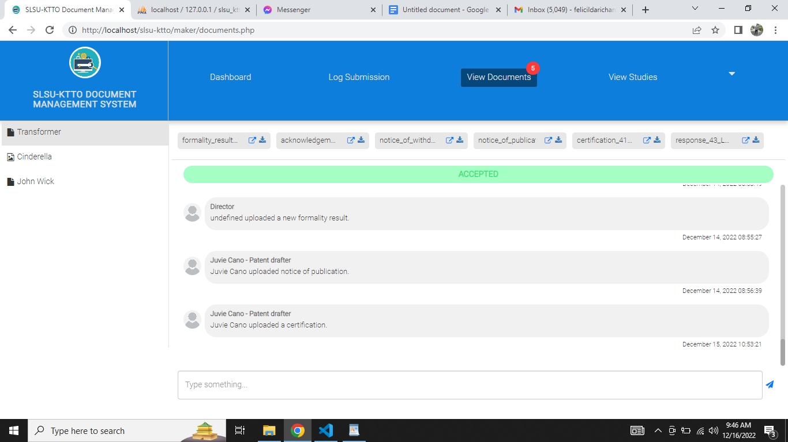

This is the part where the maker sees the list of accepted and rejected studies. Also they can also see or download the uploaded documents from the **Patent Drafters**. Lastly, they also reply to the comment.

**View Studies**

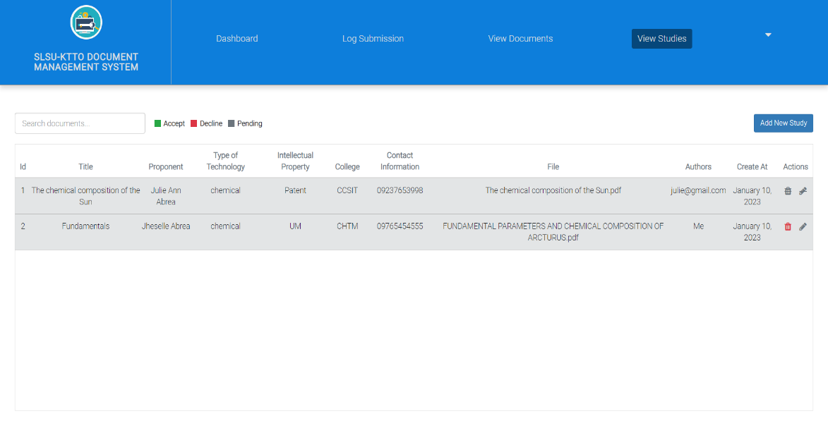

This is the part where the maker sees the list of studies.

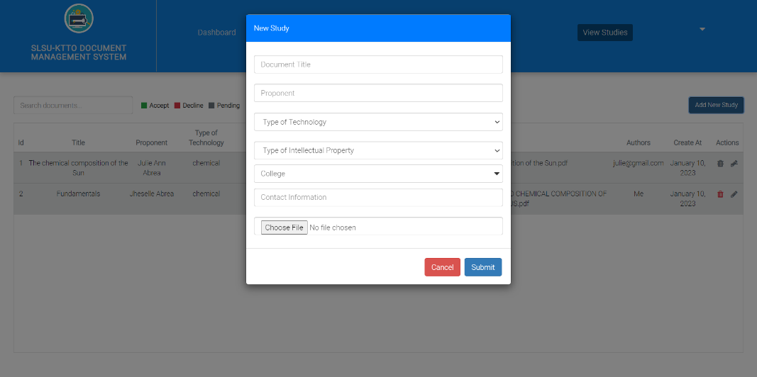

This is the part where the maker created a new study.

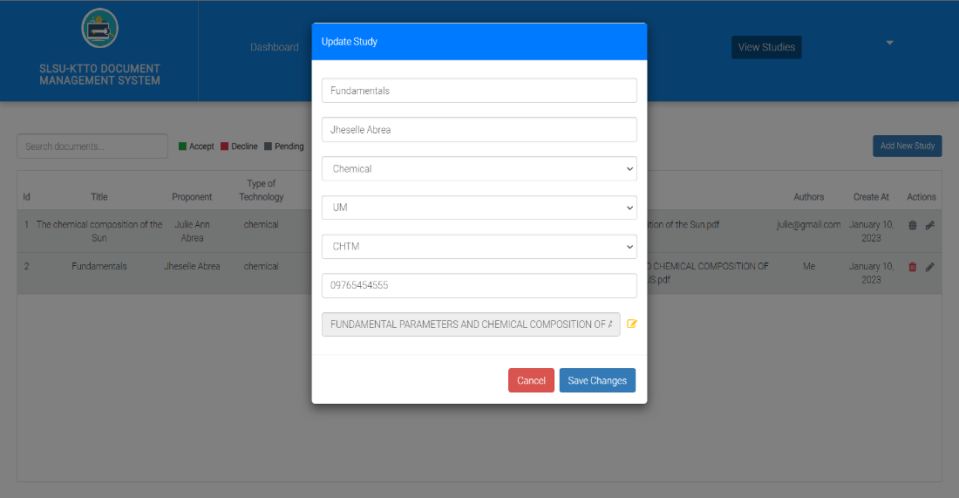

This is the part where the maker selected a specific study and wanted to perform any changes of it.

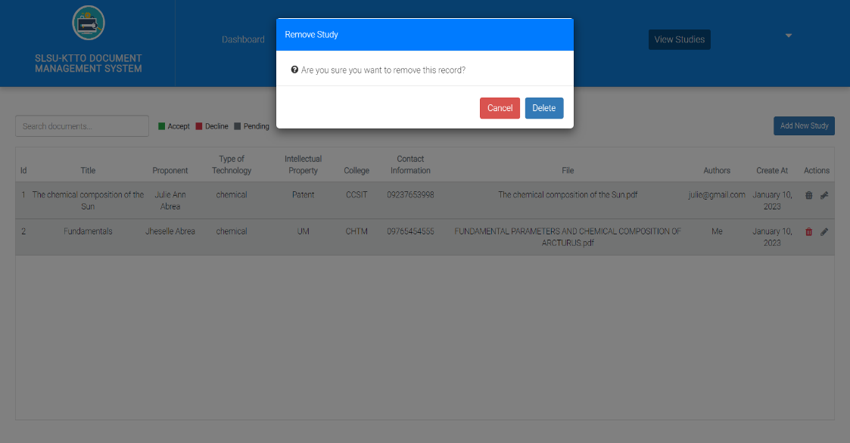

This is the part where the maker selected a specific study and wanted to remove it.

**Profile**

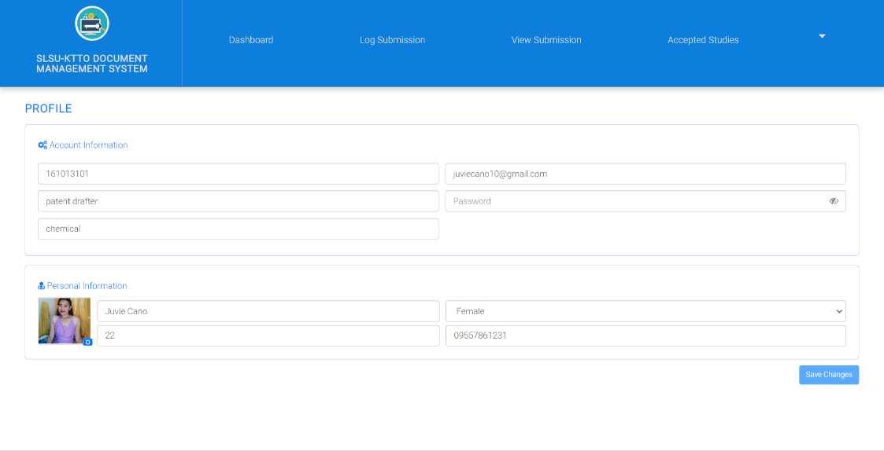

**For All Users.** This is the part where the user sees their account and personal information. They can also modify it.

**4.4 System Processes**

Figure 10 The IPO system is how the entire system procedure of Document Management System for KTT Office.

Input

Process

Output

Accepting studies(formality result,…)

Submit Studies(maker)

Reviewing files (patent)

Accept Studies(patent)

Forwarding files(patent)

Figure 10. IPO

**4.5 Development and Testing**

* **Software Development**

The system development process is anchored to the System Development Life Cycle (SDLC) waterfall model as shown in the Figure. The first phase is the requirement analysis where the developer must determine user expectations for a new or modified product. The second phase is the design of the software, where the developer design and implemented a data structure and algorithms used in the software to produce a detailed data model. The third phase is the design of the system, where the design of the system is easy to use and user-friendly which helps to avoid confusion for users. The fourth phase is the system process, where the procedure outlines the order of specific steps required to achieve a result, and a series of procedures taken together make up a process. The fifth phase is the deployment, where after the system is developed and tested several times, the system needs to undergo a deployment to ensure that the system can perform well and can accommodate the needs of the user in a real situation if there are any glitches or need to improve it can be discussed and take an action immediately. Lastly, is maintenance, where the function of the system must be maintained and secured well to make the system work well.

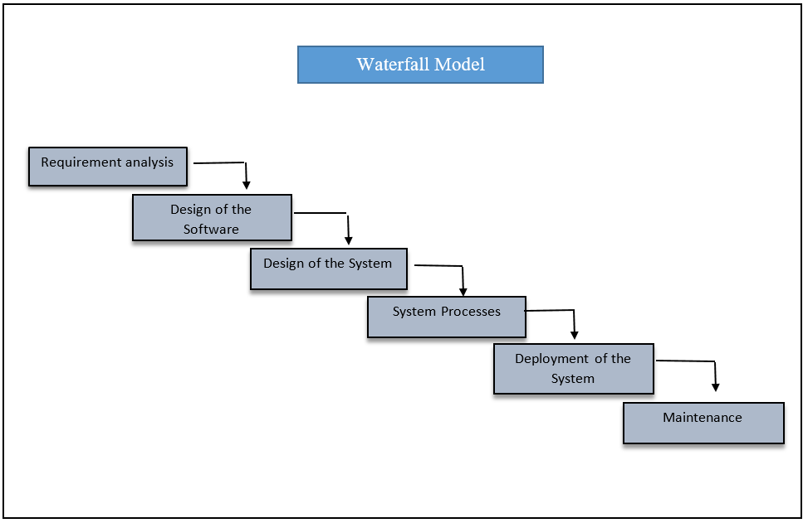

* **Hardware Specification**

|  |  |
| --- | --- |
| Hardware | Description/Specification |
| Computer/ Laptop | Intel core i3-i5 |
|  | 8GB RAM |
|  | 900 GB |
|  | Windows 10 |

* **Software Specification**

Shown in the Table 5 is the software specifications for the development of Document Management System for KTT Office.

|  |
| --- |
| **SOFTWARE** |
|  |
| Microsoft Visual Studio Code- to encode the source code |
| PHP- used for a server side programming language |
| HTML- to produced electronic text |
| CSS- to specifying how Web pages are presented |
| Javascript- for the development of the system |
| Ajax- for communicating with the server without reloading the web page |

Table 5. Software Specificstion

* **Testing**

Testing of the developed Documents Management System was partially done. Unit testing was conducted to ensure that the system functions as designed. Compatibility testing was also done to this system project to ensure that the web-based system can run using different browser such as chrome. The system can be accessible of any devices like laptop, computer, android phones not lower 6.0 android version with an updated browser.

* **Description of the System**

This system project is a web-based program; the system is fully functioning and it is user friendly to all users. The front end of the system utilizes PHP and other frameworks for web programming. The researchers also used jQuery Ajax without loading the web page, and Visual Studio for coding. The developed system is web-responsive and data-driven powered by MySQL for database functionality.

This system’s feature can create, edit, update, delete and upload the users studies. This system can also evaluate the proponents project proposal to project implementation. This system will easily track down any studies.

**IMPLEMENTATION PLAN**

**Develop**

**Test**

**Design**

**Plan**

* Develop the system of the Document Management System for KKT Office already and ready to test.
* The system works functionally
* Good condition laptop and PC help to improve the effective of the system.
* Strong internet connection can boost the effectivity of the system
* Planning and brainstorming of the proposed project.
* Make a system that can submit and upload files.
* The system can be done online.

* In UI we decided to create a layout or draft papers for designing

**CHAPTER V**

**RECOMMENDATION**

**RECOMMENDATION**

This proposed system needs some improvement to enhance the usability and effectiveness of the system. Importance is also accorded to data security which ensures the data given to the health experts are secure from third party users or unauthorized users.

**BIBLIOGRAPHY**

Adam Uzialko (2021, December). Business News Daily Staff.

<https://bit.ly/39pgY8B>

Agarkar, Mayur; Borle, Ajinkya; Deshmukh, Ashwini; Bhagat, Munmun (2012). [IEEE 2012

IEEE World Congress on Services (SERVICES) - Honolulu, HI, USA (2012.06.24-

2012.06.29)] 2012 IEEE Eighth World Congress on Services - An Enhanced Document

Management System for SME. , (), 336–339. doi:10.1109/services.2012.67

Akcay, M., ARDIÇ, İ., & Şendoğan, Ş. E. N. (2019, October). Document Management System.

In 2019 3rd International Symposium on Multidisciplinary Studies and Innovative

Technologies (ISMSIT) (pp. 1-7). IEEE. https://bit.ly/3LlYAvn

Anwar, M. A., & Ahmed, N. (2013). An e-Course file management system: A green campus

initiative. In Information and Knowledge Management (Vol. 3, No. 1, pp. 1-6).

http://citeseerx.ist.psu.edu/viewdoc/download?doi=10.1.1.952.5946&rep=rep1&type=pdf

[Bruce Malyon](https://pt.slideshare.net/BruceMalyon?utm_campaign=profiletracking&utm_medium=sssite&utm_source=ssslideview) (2016), EDMS Software - MaxxVault Company Profile

<https://pt.slideshare.net/BruceMalyon/edms-software-maxxvault-company-profile>

Elsa V. Isip (2017), Electronic Document Management System, National Library.

Kao, Chia Hung; Liu, Shin Tzu (2013). Development of a Document Management System for

Private Notion

Cloud Environment. Procedia - Social and Behavioral Sciences, 73(), 424–429.

<https://doi.org/10.1016/j.sbspro.2013.02.071>

Ugale, M. K., Patil, S. J., & Musande, V. B. (2017, October). Document management system: A

notion towards paperless office. In *2017 1st International Conference on Intelligent Systems and*

*Information Management (ICISIM)* (pp. 217-224). IEEE.

Stallings, W. (2015). Chapter 12—File Management. *Operating Systems—Internals and Design*

*Principles, Eighth Edition, Pearson Education, Inc. HA*, 522-570.

[https://docplayer.net/12000678- Chapter-12-file-management.html](https://docplayer.net/12000678-Chapter-12-file-management.html)

Steve Jones (2012), ‘eGovernment Document Management System: A case analysis of risk and

reward’*, International Journal of Information Management, Vol. 32 No. 4, pp. 396–400*

<https://bit.ly/3xQYvMe>

[Vasila Soltanaga Abbasova](https://www.researchgate.net/scientific-contributions/Vasila-Soltanaga-Abbasova-2176271108) (2020, February) MAIN CONCEPTS OF THE DOCUMENT

MANAGEMENT SYSTEM REQUIRED FOR ITS IMPLEMENTATION IN ENTERPRISES

<https://bit.ly/3vL38ok>

Yatin, et.al., January 2015, Electronic Document Management System: Malaysian Experience.

*Australian Journal of Basic and Applied Sciences*

<https://bit.ly/3vOkcd2>

**Appendices**

**Relevant Source Code**

* **Database Connection**

<?php

$server = 'localhost';

$username = 'root';

$password = '';

$database = 'slsu_kttoDb';

date_default_timezone_set('Asia/Manila');

$conn  = mysqli_connect($server, $username, $password, $database);

// echo phpinfo();

if (!$conn) {

    echo 'Unable to Connect to Database';

}

* **Add/Save/Insert**

$title = $_POST['doc_title'];

        $proponent = $_POST['proponent'];

        $technology_type = $_POST['technology_type'];

        $contact_info = $_POST['contact_info'];

        $created_at = $_POST['created_at'];

        $author = $_POST['author'];

        $status = $_POST['status'];

        $color = $_POST['color'];

        $userId = $_POST['userId'];

        $file = $_FILES['file']['name'];

        $file_tmp_name = $_FILES['file']['tmp_name'];

        $file_ex = pathinfo($file, PATHINFO_EXTENSION);

        $file_ex_loc = strtolower($file_ex);

        $filepath = '../uploads/'.$_FILES['file']['name'];

        move_uploaded_file($file_tmp_name, $filepath);

        $query = "Insert into tbl_studies values ('', '".$title."', '".$proponent."', '".$technology_type."', '".$contact_info."', '".$file."', '".$author."', '".$created_at."', '".$status."', '".$color."', 0, '".$userId."', 0)";

        $executeQuery = mysqli_query($conn, $query);

        $response = new Response();

        if($executeQuery){

          $response->status_code = 200;

          $response->message = 'New Study Successfully Added.';

        }else{

          $response->status_code = 500;

          $response->message = 'Something went wrong in saving data.';

        }

        echo json_encode($response);

* **Update/Edit**

 $file = $_FILES['updt_file']['name'];

            $file_tmp_name = $_FILES['updt_file']['tmp_name'];

            $file_ex = pathinfo($file, PATHINFO_EXTENSION);

            $file_ex_loc = strtolower($file_ex);

            $filepath = '../uploads/'.$_FILES['updt_file']['name'];

            $getFileQuery = "Select * from tbl_studies where id = '".$_POST['rowId']."'";

            $removeFileQuery = mysqli_query($conn, $getFileQuery);

            if(mysqli_num_rows($removeFileQuery) > 0){

               $row = mysqli_fetch_assoc($removeFileQuery);

               unlink('../uploads/'.$row['file']);

            }

            $query = "Update tbl_studies set title = '".$_POST['updt_title']."', proponent= '".$_POST['updt_proponent']."', technology_type = '".$_POST['updt_technology_type']."', contact_information = '".$_POST['updt_contact_information']."', file = '".$file."' where id = '".$_POST['rowId']."'";

            $executeQuery = mysqli_query($conn, $query);

            if($executeQuery){

               move_uploaded_file($file_tmp_name, $filepath);

               $response->status_code = 200;

               $response->message = "Study Successfully Updated.";

            }else{

               $response->status_code = 400;

               $response->message = "Something went wrong on updating data. Please try again";

            }

            echo json_encode($response);

* **Delete**

$query = "Delete from tbl_studies WHERE id='".$_POST['rowId']."'";

         $executeQuery = mysqli_query($conn, $query);

         $response = new Response();

         if($executeQuery){

            $response->status_code = 200;

            $response->message = "Study Successfully Deleted.";

         }else{

            $response->status_code = 400;

            $response->message = "Something went wrong in removing study. Please try again.";

         }

         echo json_encode($response);

**CURRICULUM VITAE**

**JUVIE V. CANO**

Brgy. Anahawan, Tomas Oppus, Southern Leyte

09269615923

juviecano10@gmail.com

**PERSONAL INFORMATION________ _______________________________**

Date of Birth: October 4, 2000

Age: 22

Civil Status: Single

Nickname: Juviang

Religion: Roman Catholic

Gender: Female

Place of Birth: Anahawan, Topmas Oppus, Southern Leyte

**EDUCATIONAL ATTAINMENT________ ______ ___________________ ___**

ELEMENTARY EDUCATION

School Name: ANAHAWAN ELEMENTARY SCHOOL

Address: Anahawan, Tomas Oppus, Southern Leyte

School Year: 2012 - 2013

Status: Completed

JUNIOR HIGH SCHOOL EDUCATION

School Name: DR. RATH MEMORIAL INSTITUE FOUNDATION INCORPORATED

Address: Cambite, Tomas Oppus, Southern Leyte

School Year: 2016 - 2017

Status: Junior High Graduate

SENIOR HIGH SCHOOL EDUCATION

School Name: DON AGUSTIN F. ESCANO HIGH SCHOOL

Address: Bogo, Tomas Oppus, Southern Leyte

School Year: 2018 - 2019

Status: Senior High Graduate

TERTIARY EDUCATION

School Name: SOUTHERN LEYTE STATE UNIVERSITY

Course: Bachelor of Science in Information Technology

Major: Programming

Address: Brgy. San Roque, Sogod, Southern Leyte

School Year: 2022 - 2023

Status: Continuing

**SKILLS______________________________ ______ ___________________ ___**

Coding, Editing videos.

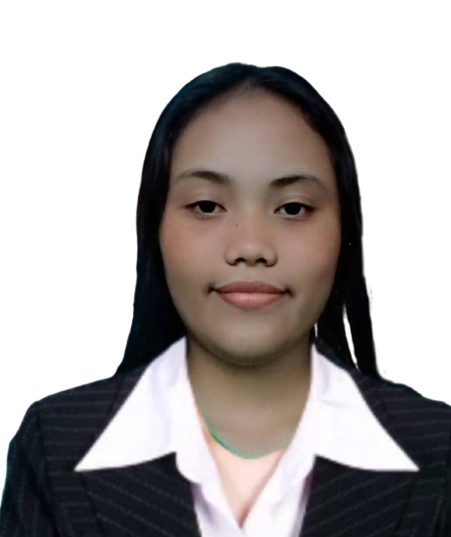**CURRICULUM VITAE**

**JULIE ANN ABREA**

Brgy. Anahawan, Tomas Oppus, Southern Leyte

09635835535

Julieannabrea2000@gmail.com

**PERSONAL INFORMATION________ _______________________________**

Date of Birth: July 18, 2000

Age: 22

Civil Status: Single

Nickname: Julie

Religion: Roman Catholic

Gender: Female

Place of Birth: Anahawan, Topmas Oppus, Southern Leyte

**EDUCATIONAL ATTAINMENT________ ______ ___________________ ___**

ELEMENTARY EDUCATION

School Name: CAWAYAN ELEMENTARY SCHOOL

Address: Cawayan, Tomas Oppus, Southern Leyte

School Year: 2012 - 2013

Status: Completed

JUNIOR HIGH SCHOOL EDUCATION

School Name: DR. RATH MEMORIAL INSTITUE FOUNDATION INCORPORATED

Address: Cambite, Tomas Oppus, Southern Leyte

School Year: 2016 - 2017

Status: Junior High Graduate

SENIOR HIGH SCHOOL EDUCATION

School Name: DON AGUSTIN F. ESCANO HIGH SCHOOL

Address: Bogo, Tomas Oppus, Southern Leyte

School Year: 2018 - 2019

Status: Senior High Graduate

TERTIARY EDUCATION

School Name: SOUTHERN LEYTE STATE UNIVERSITY

Course: Bachelor of Science in Information Technology

Major: Programming

Address: Brgy. San Roque, Sogod, Southern Leyte

School Year: 2022 - 2023

Status: Continuing

**SKILLS______________________________ ______ ___________________ ___**

Writing song lyrics, editing photos.

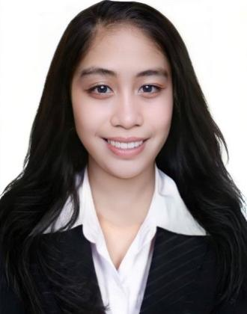**CURRICULUM VITAE**

**JHESELLE D. OBRA**

Brgy. Anahawan, Tomas Oppus, Southern Leyte

09950221081

Jheselleobra122@gmail.com

**PERSONAL INFORMATION________ _______________________________**

Date of Birth: May 18, 2000

Age: 22

Civil Status: Single

Nickname: Selle

Religion: Christian Catholic

Gender: Female

Place of Birth: Zone 5, Sogod, Southern Leyte

**EDUCATIONAL ATTAINMENT________ ______ ___________________ ___**

ELEMENTARY EDUCATION

School Name: ANAHAWAN ELEMENTARY SCHOOL

Address: Anahawan, Tomas Oppus, Southern Leyte

School Year: 2012 - 2013

Status: Completed

JUNIOR HIGH SCHOOL EDUCATION

School Name: DR. RATH MEMORIAL INSTITUE FOUNDATION INCORPORATED

Address: Cambite, Tomas Oppus, Southern Leyte

School Year: 2016 - 2017

Status: Junior High Graduate

SENIOR HIGH SCHOOL EDUCATION

School Name: DON AGUSTIN F. ESCANO HIGH SCHOOL

Address: Bogo, Tomas Oppus, Southern Leyte

School Year: 2018 - 2019

Status: Senior High Graduate

TERTIARY EDUCATION

School Name: SOUTHERN LEYTE STATE UNIVERSITY

Course: Bachelor of Science in Information Technology

Major: Programming

Address: Brgy. San Roque, Sogod, Southern Leyte

School Year: 2022 - 2023

Status: Continuing

**SKILLS______________________________ ______ ___________________ ___**

Editing Videos/Photos.

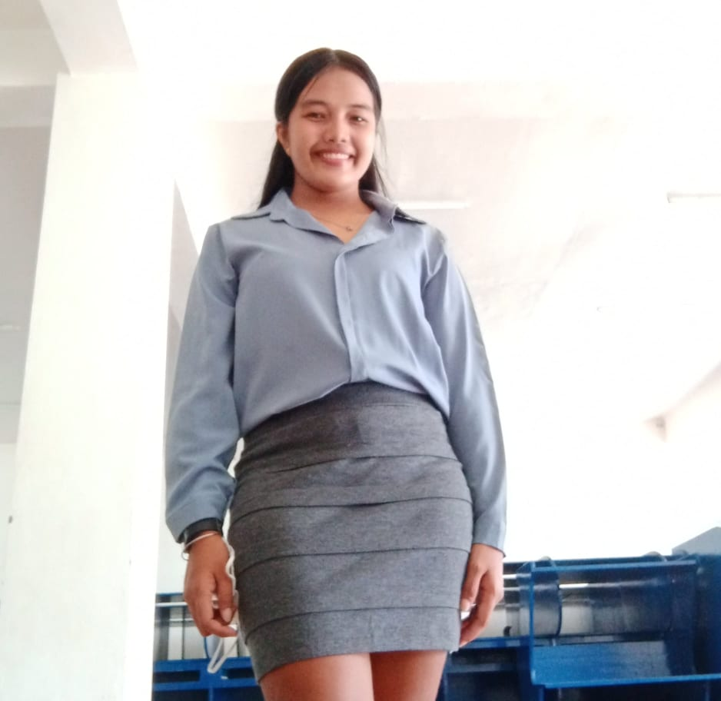**CURRICULUM VITAE**

**JELLY ANN COSTILLAS**

Brgy. Bactul 1, Maasin, Southern Leyte

09381303838

Lyanncostillas123@gmail.com

**PERSONAL INFORMATION________ _______________________________**

Date of Birth: August 13, 2000

Age: 22

Civil Status: Single

Nickname: Jelly

Religion: Roman Catholic

Gender: Female

Place of Birth: Anahawan, Topmas Oppus, Southern Leyte

**EDUCATIONAL ATTAINMENT________ ______ ___________________ ___**

ELEMENTARY EDUCATION

School Name: BACTUL 1 MULTI GRADE SCOOL

Address: Bactul 1, Maasin, Southern Leyte

School Year: 2012 - 2013

Status: Completed

JUNIOR HIGH SCHOOL EDUCATION

School Name: LIBHU NATIONAL HIGH SCHOOL

Address: Libhu, Maasin, Southern Leyte

School Year: 2016 - 2017

Status: Junior High Graduate

SENIOR HIGH SCHOOL EDUCATION

School Name: LIBHU NATIONAL HIGH SCHOOL

Address: Libhu, Maasin, Southern Leyte

School Year: 2018 - 2019

Status: Senior High Graduate

TERTIARY EDUCATION

School Name: SOUTHERN LEYTE STATE UNIVERSITY

Course: Bachelor of Science in Information Technology

Major: Programming

Address: Brgy. San Roque, Sogod, Southern Leyte

School Year: 2022 - 2023

Status: Continuing

**SKILLS____________________________ ______ ___________________ ___**

Writing poems, singing

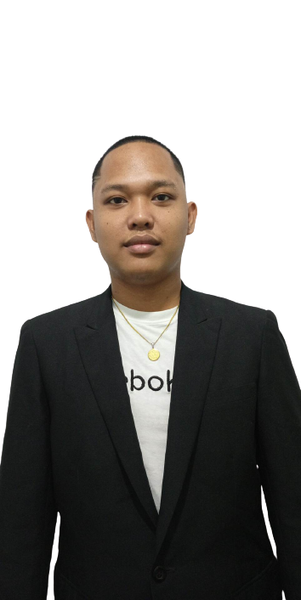**CURRICULUM VITAE**

**IAN RITZ CALINDAO**

Brgy. Poblacion, Liloan, Southern Leyte

09615289962

calindaoircian@gmail.com

**PERSONAL INFORMATION________ _______________________________**

Date of Birth: March 11, 2001

Age: 21

Civil Status: Single

Nickname: Ian

Religion: Roman Catholic

Gender: Male

Place of Birth: Poblacion, Liloan, Southern Leyte

**EDUCATIONAL ATTAINMENT________ ______ ___________________ ___**

ELEMENTARY EDUCATION

School Name: LILOAN CENTRAL SCHOOL

Address: Caducan, Liloan, Southern Leyte

School Year: 2012 - 2013

Status: Completed

JUNIOR HIGH SCHOOL EDUCATION

School Name: LILOAN TECHNICAL VOCATIONAL NATIONAL HIGH SCHOOL

Address: Poblacion, Liloan, Southern Leyte

School Year: 2016 - 2017

Status: Junior High Graduate

SENIOR HIGH SCHOOL EDUCATION

School Name: LILOAN TECHNICAL VOCATIONAL NATIONAL HIGH SCHOOL

Address: Poblacion, Liloan, Southern Leyte

School Year: 2018 - 2019

Status: Senior High Graduate

TERTIARY EDUCATION

School Name: SOUHERN LEYTE STATE UNIVERSITY

Course: Bachelor of Science in Information Technology

Major: Programming

Address: Brgy. San Roque, Sogod, Southern Leyte

School Year: 2022 - 2023

Status: Continuing

**SKILLS______________________________ ______ ___________________ ___**

Writing song lyrics

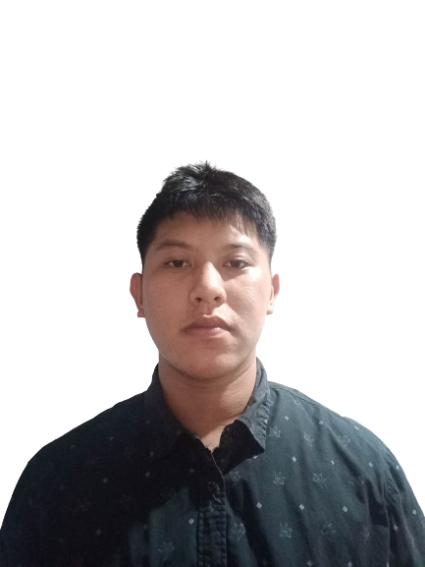

**CURRICULUM VITAE**

**RONALD RIVAS**

Brgy. Canha Ayon, Hindang, Leyte

09978522377

trapkin0997@gmail.com

**PERSONAL INFORMATION________ _______________________________**

Date of Birth: October 28, 1998

Age: 24

Civil Status: Single

Nickname: Nald

Religion: Roman Catholic

Gender: Female

Place of Birth: Brgy. Canha Ayon, Hindang, Leyte

**EDUCATIONAL ATTAINMENT________ ______ ___________________ ___**

ELEMENTARY EDUCATION

School Name: STO. NINO ELEMENTARY SCHOOL

Address: Bucandala 3 Imus Cavite

School Year: 2012 - 2013

Status: Completed

JUNIOR HIGH SCHOOL EDUCATION

School Name: CAPUDLUSAN, NATIONAL HIGH SCHOOL

Address: Capudlusan, Hindang, Leyte

School Year: 2016 - 2017

Status: Junior High Graduate

SENIOR HIGH SCHOOL EDUCATION

School Name: BAYBAY CITY HIGH SCHOOL

Address: Baybay, City, Leyte

School Year: 2018 - 2019

Status: Senior High Graduate

TERTIARY EDUCATION

School Name: SOUTHERN LEYTE STATE UNIVERSITY

Course: Bachelor of Science in Information Technology

Major: Programming

Address: Brgy. San Roque, Sogod, Southern Leyte

School Year: 2022 - 2023

Status: Continuing

**SKILLS______________________________ ______ ___________________ ___**

Sporty.